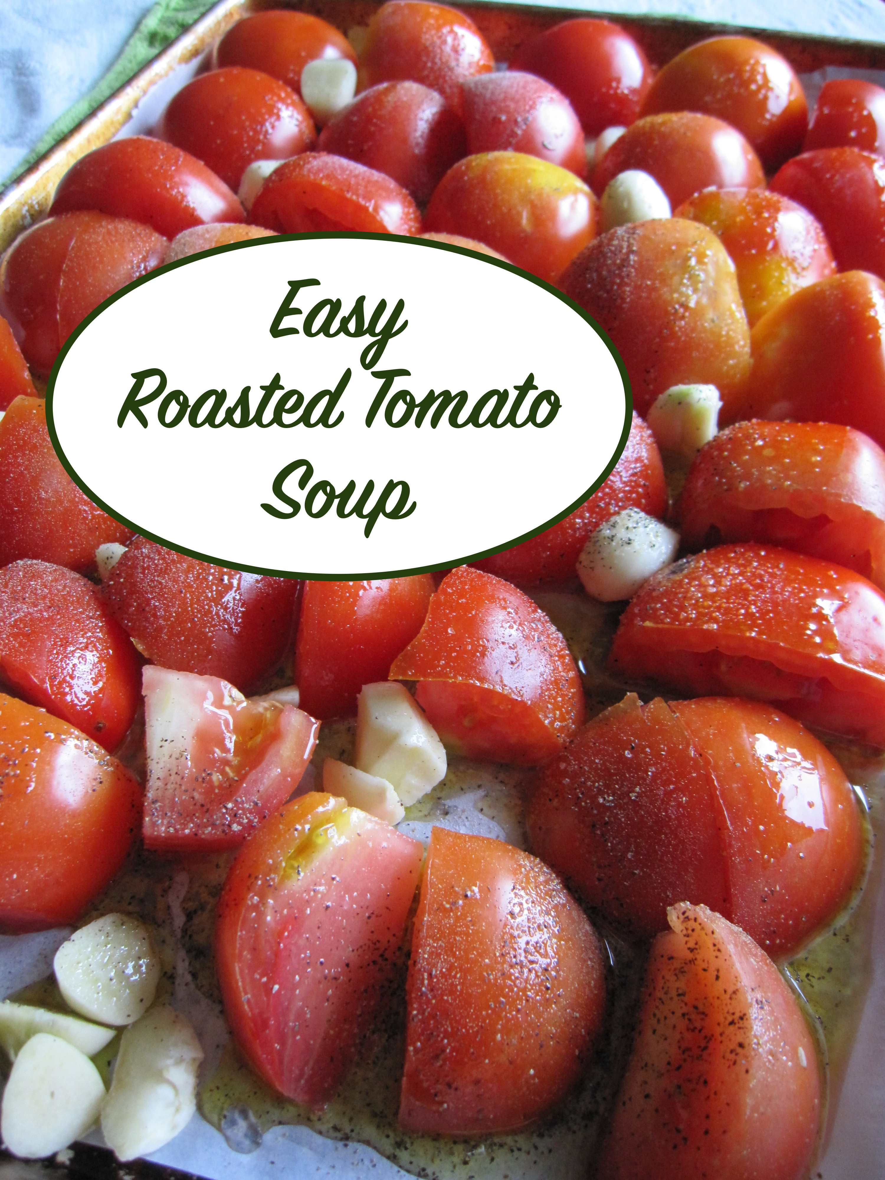
Easy Roasted Tomato Soup
By Chrissy@mythankfultable.com

Ingredients:

Fresh tomatoes (I use enough to fill two large cookie sheets when halved)
One head of garlic
Olive oil, to drizzle
Sea salt
Pepper
One large container of stock of your choice (chicken or vegetable)

Directions:
Slice tomatoes in half, and place, cut side down, onto parchment lined cookie sheet
Peel garlic and place amongst tomatoes
Drizzle with olive oil, sea salt, and fresh cracked pepper

Bake at 350* for 50 minutes or more, until tomatoes are roasted and caramelized.
Place roasted tomatoes and garlic in food processor or in stock pot with stock of choice, and blend (I use the immersion blender)
Blend until smooth.

Add milk, cream, cheese, additional herbs to taste if desired.

Enjoy!
